TP 8 des architectures logicielles
Séance 8 : Installation STS IDE pour Spring Framework

Install Spring Tool Suite for existing Eclipse IDE

Spring Tool Suite (STS) is an Eclipse-based IDE which is optimized for developing Spring framework-based projects. It can be either installed as a standalone IDE or as a plug-in in Eclipse. If you are already using Eclipse IDE, you may consider installing STS as a plug-in for your existing Eclipse, because that’s faster than downloading the STS separately.
Installing STS from within Eclipse IDE is pretty simple, follow these steps:
- Click Help > Eclipse Marketplace… from Eclipse’s main menu. The Eclipse Marketplace dialog appears, type Spring Tool Suite or STS into the Find textfield and hit Enter. Eclipse will send query to its server and display results as shown below:
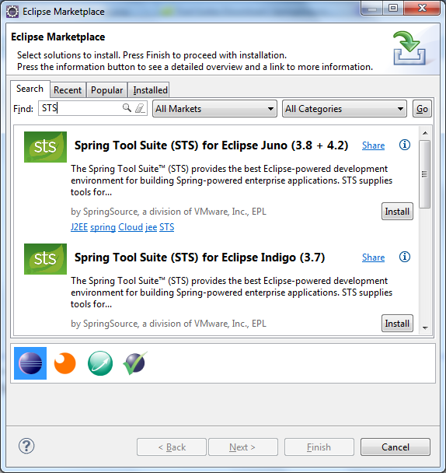
- Select the version that matches your Eclipse’s version and click Install button. Here we select Spring Tool Suite (STS) for Eclipse Juno (3.8 + 4.2). It takes a while for Eclipse to fetch the details and show the features of STS as shown below:
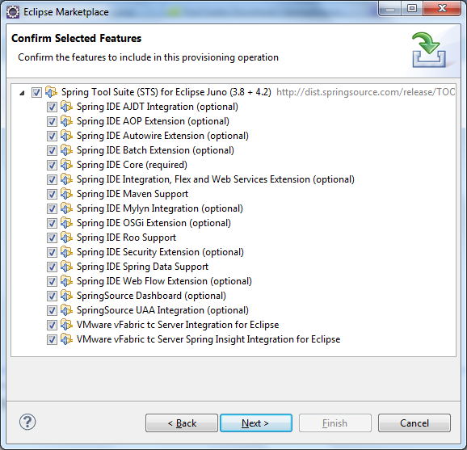
- All features are selected by default, click Next. The Review Licenses screen appears: 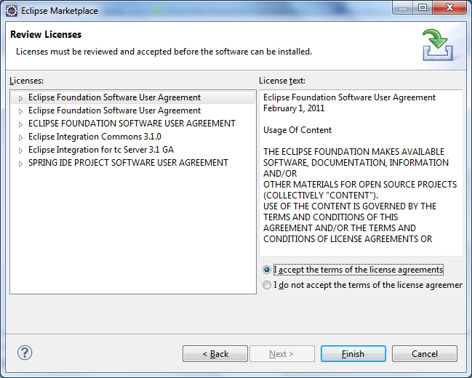

- Select I accept the terms of the license agreements, and then click Finish. Eclipse will install STS and display the progress:
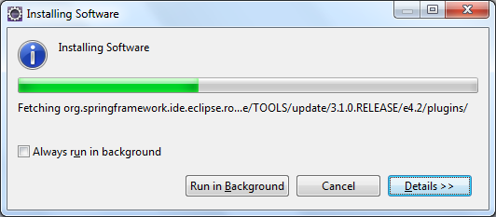
- After the installation completed, Eclipse asks to restart the IDE:
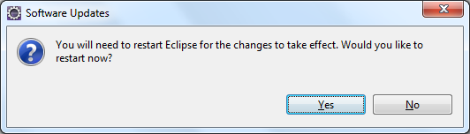
- Click Yes to restart the IDE. When Eclipse restarted, you will see some Spring natures are added to the IDE. The first thing is Spring perspective: 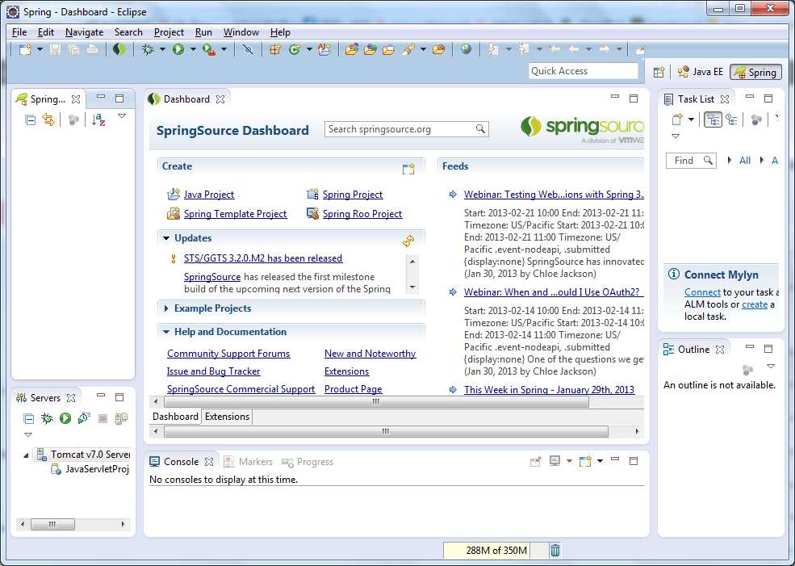
- The menu File > New now comes with some Spring projects: 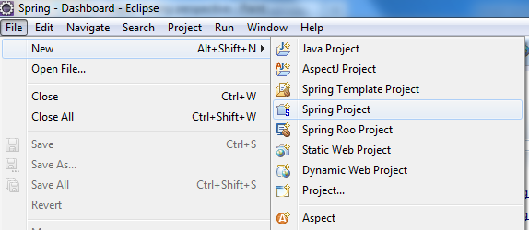
- The menu Window > Open Perspective now has Spring perspective:
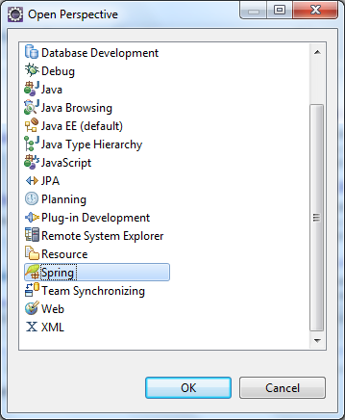
- We can also show Spring views from the menu Window > Show View: 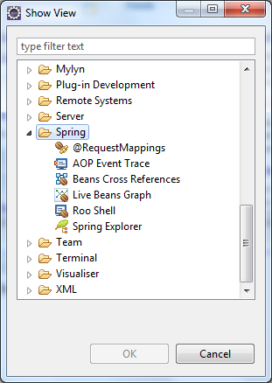
- And new options in the New Server Runtime Environment dialog:
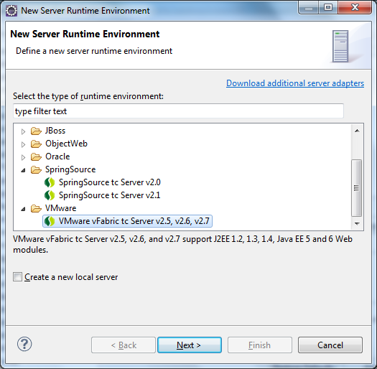

Now you are ready to develop your Spring-based projects in your favorite Eclipse IDE.

